REPORT


COMPLEMENTS ON UNSUPERVISED
LEARNING

MENTOR :-- MEMBERS INCLUDED:--
BADIH GHATTAS 1) LUCAS DE LA BROSSE
2) SHISHIR DUBEY

LAB 1

AIM :
1) To generate a dataset named Toys with n=50 observations and p=20 variables which satisfies the following conditions,

Y ∈ {− 1 , 1 } following a uniform distribution

With probability 0.7,

x i ∼ yN(i, 1 ), i = 1 , 2 , 3
x i ∼ yN( 0 , 1 ), i = 4 , 5 , 6

else

x i ∼ yN( 0 , 1 ), i = 1 , 2 , 3
x i ∼ yN(i − 3 , 1 ), i = 4 , 5 , 6

For the other variables :

x i ∼ N( 0 , 20 ), i = 7 ,. . . , p

2) To perform T-Test on the generated Toys dataset and to rank each variable in the dataset based on the p-value.

3) To rank each variable in the dataset based on the Fisher Discriminative Score.

R-Code :

###### TOYS DATASET
toys<-as.data.frame(matrix(0, ncol = 20, nrow = 50))

## Variable y with a uniform distribution where y∈ {− 1 , 1 }
y<-ifelse(runif(50,0,1)<0.5,1,-1)
table(y)

toy <- function(n,p)
{
z<-runif(n)
toys<-as.data.frame(matrix(0, ncol = p, nrow = n))
for (i in 1:n){
if (z[i]<0.7){
for (j in 1:3){
toys[i,j]<-y[i]*rnorm(1,j,1)
}
for (j in 4:6){
toys[i,j]<-y[i]*rnorm(1,0,1)
}
}
else {
for (j in 1:3){
toys[i,j]<-y[i]*rnorm(1,0,1)
}
for (j in 4:6){
toys[i,j]<-y[i]*rnorm(1,j-3,1)
}
}
}

for (j in 7:p){
toys[,j]<-rnorm(n,0,1)
}
return(toys)
}

toys <- toy(50,20)
y <- as.factor(y)

## Scatterplot for the toys dataset
pairs(toys[,1:6],col=3+y)

## T-TEST
a <- rep(0,20)
for(i in 1:20) {
a[i]<- (t.test(toys[y==1,i],toys[y==-1,i])$p.value)
}
order(a)

## FISHER DISCRIMINATIVE SCORE
FDS <- rep(0,20)
for(i in 1:20) {
FDS[i]<- abs((mean(toys[y==1,i])-mean(toys[y==-1,i]))/(sd(toys[y==1,i])-sd(toys[y==-1,i])))
}
order(FDS,decreasing = TRUE)

OUTPUT :

=> Scatterplot :
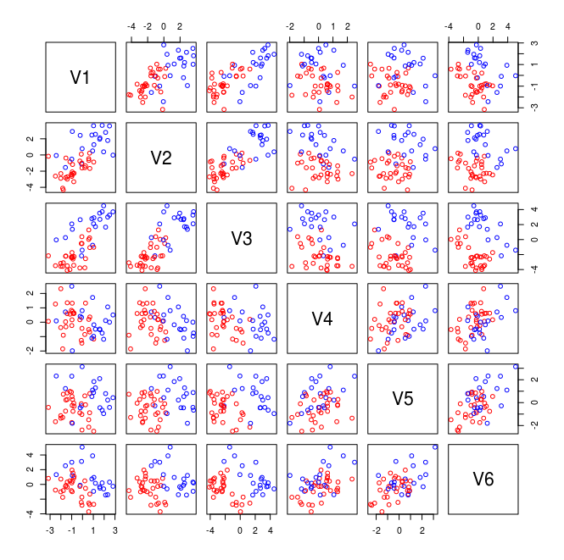

=> Ranking of all the variables in the toys dataset based on the p-value generated by the T-Test :

[1] 3 2 1 6 5 4 8 20 13 17 18 16 19 12 10 11 15 9 7 14

=> Ranking of all the variables in the toys dataset based on the Fisher Discriminative Score :

[1] 3 2 1 6 5 4 8 20 13 17 18 16 19 12 10 11 15 9 7 14

CONCLUSION :

- By analyzing the scatter plot generated by the toys dataset, we can conclude that the data are linearly separable with high probability, decreasing with the sample size.

- When compared with the truth, both the results of rankings obtained from T-Test statistic and from Fisher Discriminative Score, show that approximately always the first 6 explanatory variables are ranked at the top and this solidifies the truth that we defined 70% probability for the first 6 explanatory variables and 30% probability for the rest of the variables.

LAB 3

AIM 1:- Compute the rankings of the varibles in three simulation models using weight vector of the SVM.

R-CODE
## SVM

library(e1071)

svmrfeFeatureRanking = function(x,y){
n = ncol(x)

survivingFeaturesIndexes = seq(1:n)
featureRankedList = vector(length=n)
rankedFeatureIndex = n

while(length(survivingFeaturesIndexes)>0){
#train the support vector machine
svmModel = svm(x[, survivingFeaturesIndexes], y, cost = 10, cachesize=500,
scale=F, type="C-classification", kernel="linear" )

#compute the weight vector
w = t(svmModel$coefs)%*%svmModel$SV

#compute ranking criteria
rankingCriteria = w * w

#rank the features
ranking = sort(rankingCriteria, index.return = TRUE)$ix

#update feature ranked list
featureRankedList[rankedFeatureIndex] = survivingFeaturesIndexes[ranking[1]]
rankedFeatureIndex = rankedFeatureIndex - 1

#eliminate the feature with smallest ranking criterion
(survivingFeaturesIndexes = survivingFeaturesIndexes[-ranking[1]])

}

return (featureRankedList)
}

svmrfeFeatureRanking(toys,y)

## RESULT
## 6 3 4 2 20 13 5 11 17 14 7 9 12 19 1 15 18 8 10 16

AIM3:- Compute the forward stepwise introduction of the variables in decreasing order of importance to select the optimal number of features to keep in your model.Use any of the previously computed rankings and any learning model of your choice .
Where , D=Learning Sample .Split the data into D=D1 U D2
compute variables importance using D1,X⁽¹⁾ ,……,X^{(p)}
For I=1,…….,M=50
Randomly split with stratification D2 = D_{L} U D_{T}
For k= 1,……..,p

Learn the model M^{k} =f (X⁽¹⁾,...., X^{(k)},D_{L})
Er^{k}_{i}= Test (M^{k},D_{T})
Er^{k}=1/50Er^{k}_{l}
kopt = Arg min_{k}{Er^{k}}

R-CODE

library(rpart)
nr <- nrow(toys)
p <- ncol(toys)-1

## Splitting the toys dataset to D1 and D2

ind <- sample(nr,nr/3)
dataset1 <- toys[-ind,]
dataset2 <- toys[ind,]

## Computing variable importance using D1
library(randomForest)
forest <- randomForest(y~.,data = dataset1)
##forest <- rpart(y~.,dataset1)
vimp <- order(VI <- forest$importance, decreasing = TRUE)
##vimp <- rownames(as.data.frame(forest$variable.importance))
m <- matrix(nrow = nr, ncol = p)
nr1 <- nrow(dataset2)
for(i in 1:nr){

ind1 <- sample(nr1,nr1/3)
learn <- dataset2[-ind1,]
test <- dataset2[ind1,]
learn=as.data.frame(cbind(y=learn$y,learn[,vimp]))
test=as.data.frame(cbind(y=test$y,test[,vimp]))
for(j in 2:ncol(learn)){
f_model <- randomForest(learn[,1]~.,data = learn[,c(1,2:j)])
##f_model <- rpart(y~.,learn[,c(1,2:j)])
pred = predict(f_model,newdata = test[,c(1,2:j)],type = "class")
m[i,j-1] <- mean(test[,1] != pred)
}
}
x <- apply(m,2,mean)
which.min(x)
plot(x,type = 'l',xlab = "Ranked Variables",ylab = "Mean Misclassification Error")
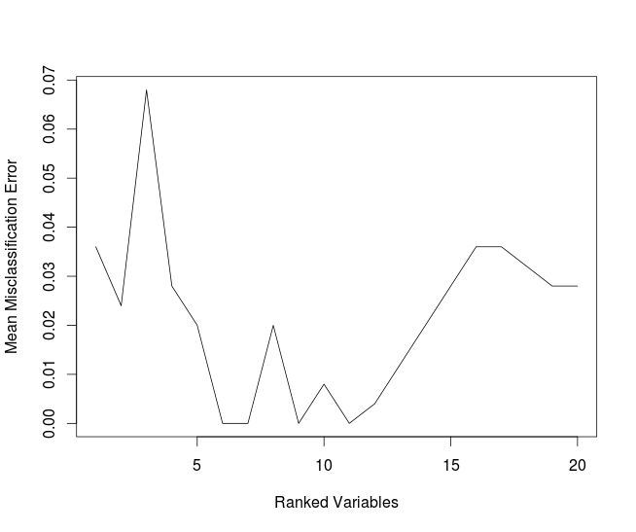
OUTPUT:-

CONCLUSION

